## Customer Requirements Speciﬁcation

**SAG WEB**

**ــــــــــــــــــــــــــــــــــــــــــــــــــــــــــــــــــــــــــــــــــــــــــــــــــــــــــــــــــــــــــــــــــــــــــــــــــــــــــــــــــــــــــــــــــــــــــــــــــــــــــــــــــــــــــــــــــــــــــــــ**

**Table of Contents**

Document Status…………………………………………………………………. 1

Document History………………………………………………………………… 1

Reference Document……………………………………………………………. 2

Project Description………………………………………………………………. 3

# Document Status:

|  |  |  |
| --- | --- | --- |
| **Name** | PO_SAG_CRS_WEB | |
| **Version** | V1.4 | |
| **Status** | Proposed | |
| **Author** | MH | |
| **Date** | [15-12-2022] | |
| **Team Approval** | AM |  |
| **Mentor Approval** | AY | Approved |
| **Final Approval** | SK & ES | Not Approved |

# 

# Document History:

|  |  |  |  |
| --- | --- | --- | --- |
| **Version** | **Author** | **Date** | **Change** |
| 1.0 | AM | [8-9-2021] | * Initial Creation |
| 1.1 | AM | [14-11-2022] | * Edit Key Element |
| 1.2 | MH | [6-12-2022] | * Add Context system * Edit Key-Element |
| 1.3 | MH | [8-12-2022] | * Edit Requirements |
| 1.4 | MH | [15-12-2022] | * Edit Requirements |

# Reference Document:

|  |  |  |  |
| --- | --- | --- | --- |
| **Ref.number** | **Doc.Name** | **Version** | **Status** |
| 1 | PO_SAG_CR_WEB | V1.5 | Released |

Project Description:

Definition:

The project consists of Website and Dashboard. The Website is for showing our product and enable the user the place an order. The Dashboard is for Admin control to show an overview and statistics about the product.

Features:

* You can buy the product through the E-commerce Website.
* A dashboard to manage the data.

Key Elements:

* The website shall display the product.
* Customer shall place and track orders.
* User shall have an account.
* Users shall send feedback and report technical issues.
* Dashboard shall vary according to the user's type.
* Dashboard admin shall see statistics and summary about the website.
* Dashboard admin shall handle payment logs.
* Dashboard admin shall handle and keep track of customers.
* Dashboard owner shall handle and keep tracking user's dashboard
* Dashboard admin shall keep track of stock.

# System Context:

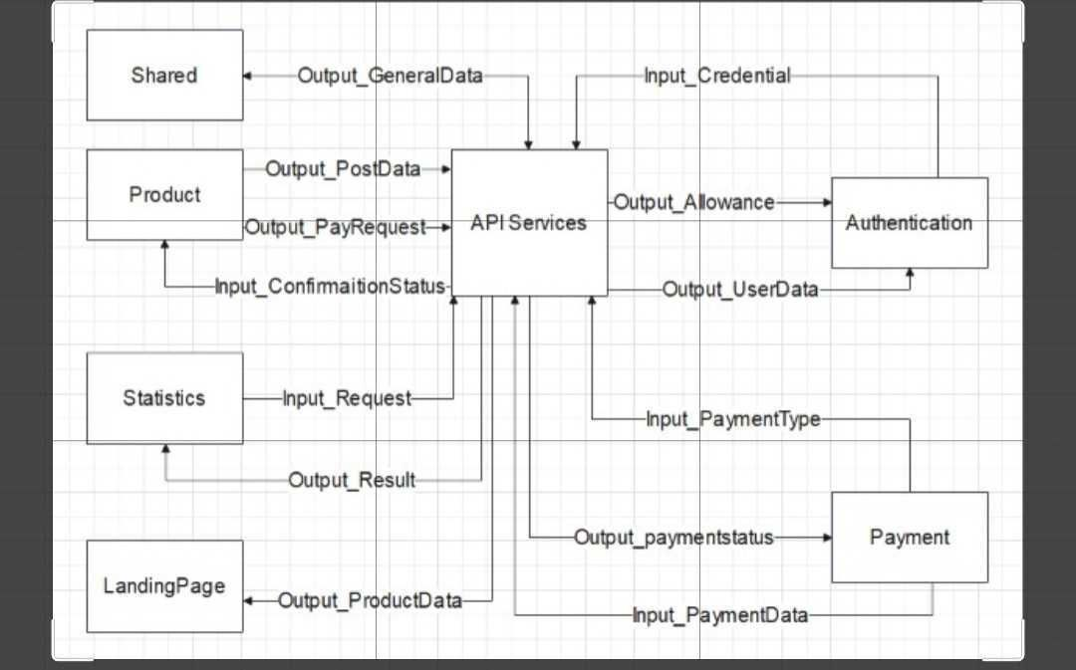

# CRS Requirements:

## Authentication:

|  |  |  |  |
| --- | --- | --- | --- |
| **Req_ID** | PO_SAG_CRS_***001***-V1.1 | **Covers** | PO_SAG_CR_WEB_***003***-V1.2 |
| **Description** | User shall be able create account using email. | | |

|  |  |  |  |
| --- | --- | --- | --- |
| **Req_ID** | PO_SAG_CRS_***002***-V1.1 | **Covers** | PO_SAG_CR_WEB_***003***-V1.2 |
| **Description** | User shall be able login to a pre-existing account. | | |

|  |  |  |  |
| --- | --- | --- | --- |
| **Req_ID** | PO_SAG_CRS_***003***-V1.1 | **Covers** | PO_SAG_CR_WEB_***003***-V1.2 |
| **Description** | User / admin shall sign in using google authentication. | | |

|  |  |  |  |
| --- | --- | --- | --- |
|  |  |  |  |
|  |  | | |

|  |  |  |  |
| --- | --- | --- | --- |
| **Req_ID** | PO_SAG_CRS_***004***-V1.1 | **Covers** | PO_SAG_CR_WEB_***003***-V1.2 |
| **Description** | Credentials shall validate entered email and password. | | |

|  |  |  |  |
| --- | --- | --- | --- |
|  | ***5*** |  |  |
|  |  | | |

|  |  |  |  |
| --- | --- | --- | --- |
| **Req_ID** | PO_SAG_CRS_***006***-V1.1 | **Covers** | PO_SAG_CR_WEB_***005***-V1.2 |
| **Description** | Role shall set by dashboard owner to user / admin. | | |

## Landing_Page:

|  |  |  |  |
| --- | --- | --- | --- |
| **Req_ID** | PO_SAG_CRS_***007***-V1.2 | **Covers** | PO_SAG_CR_WEB_***001***-V1.2 |
| **Description** | LandingPage shall show feature about product. | | |

|  |  |  |  |
| --- | --- | --- | --- |
| **Req_ID** | PO_SAG_CRS_***008***-V1.0 | **Covers** | PO_SAG_CR_WEB_***001***-V1.2 |
| **Description** | LandingPage shall show information about product. | | |

|  |  |  |  |
| --- | --- | --- | --- |
|  | ***09*** |  |  |
|  |  | | |

|  |  |  |  |
| --- | --- | --- | --- |
| **Req_ID** | PO_SAG_CRS_***010***-V1.0 | **Covers** | PO_SAG_CR_WEB_***001***-V1.2 |
| **Description** | LandingPage shall show users' reviews about product. | | |



|  |  |  |  |
| --- | --- | --- | --- |
| **Req_ID** | PO_SAG_CRS_***011***-V1.0 | **Covers** | PO_SAG_CR_WEB_***001***-V1.2 |
| **Description** | User shall contact us through LandingPage. | | |

|  |  |  |  |
| --- | --- | --- | --- |
|  |  |  |  |
|  |  | | |

## Payment:











|  |  |  |  |
| --- | --- | --- | --- |
| **Req_ID** | PO_SAG_CRS_***015***-V1.0 | **Covers** | PO_SAG_CR_WEB_***002***-V1.3 |
| **Description** | User shall choose payment process between payment or cash on delivery. | | |

|  |  |  |  |
| --- | --- | --- | --- |
| **Req_ID** | PO_SAG_CRS_***013***-V1.0 | **Covers** | PO_SAG_CR_WEB_***002***-V1.3 |
| **Description** | User shall enter his/her payment information. | | |

|  |  |  |  |
| --- | --- | --- | --- |
| **Req_ID** | PO_SAG_CRS_***014***-V1.0 | **Covers** | PO_SAG_CR_WEB_***002***-V1.3 |
| **Description** | User shall know the payment process of product is complete or not. | | |

|  |  |  |  |
| --- | --- | --- | --- |
| **Req_ID** | PO_SAG_CRS_***016***-V1.0 | **Covers** | PO_SAG_CR_WEB_***002***-V1.3 |
| **Description** | User shall see the order status. | | |

|  |  |  |  |
| --- | --- | --- | --- |
| **Req_ID** | PO_SAG_CRS_***017***-V1.0 | **Covers** | PO_SAG_CR_WEB_***002***-V1.3 |
| **Description** | Dashboard Admin shall handle track the order. | | |

## Shared:

|  |  |  |  |
| --- | --- | --- | --- |
| **Req_ID** | PO_SAG_CRS_***017***-V1.1 | **Covers** | PO_SAG_CR_WEB_***003***-V1.2 |
| **Description** | User shall edit his profile through settings. | | |

|  |  |  |  |
| --- | --- | --- | --- |
| **Req_ID** | PO_SAG_CRS_***018***-V1.1 | **Covers** | PO_SAG_CR_WEB_***003***-V1.2 |
| **Description** | User shall views about us page through settings. | | |

|  |  |  |  |
| --- | --- | --- | --- |
| **Req_ID** | PO_SAG_CRS_***019***-V1.1 | **Covers** | PO_SAG_CR_WEB_***004***-V1.2 |
| **Description** | Users shall send feedback | | |

|  |  |  |  |
| --- | --- | --- | --- |
| **Req_ID** | PO_SAG_CRS_***020***-V1.0 | **Covers** | PO_SAG_CR_WEB_***004***-V1.2 |
| **Description** | Feedback shall consists of title, description and Rating | | |



|  |  |  |  |
| --- | --- | --- | --- |
| **Req_ID** | PO_SAG_CRS_***022***-V1.0 | **Covers** | PO_SAG_CR_WEB_***004***-V1.2 |
| **Description** | User shall report (technical / non-technical) issues. | | |

## Statistical:

|  |  |  |  |
| --- | --- | --- | --- |
| **Req_ID** | PO_SAG_CRS_***023***_V1.1 | **Covers** | PO_SAG_CR_WEB_***005***-V1.3 |
| **Description** | Dashboard owner shall manage dashboard and control it. | | |

|  |  |  |  |
| --- | --- | --- | --- |
|  |  |  |  |
|  |  | | |

|  |  |  |  |
| --- | --- | --- | --- |
|  |  |  |  |
|  |  | | |

|  |  |  |  |
| --- | --- | --- | --- |
| **Req_ID** | PO_SAG_CRS_***026***-V1.1 | **Covers** | PO_SAG_CR_WEB_***006***-V1.3 |
| **Description** | Dashboard admin shall see summary about number of users. | | |

|  |  |  |  |
| --- | --- | --- | --- |
| **Req_ID** | PO_SAG_CRS_***027***-V1.1 | **Covers** | PO_SAG_CR_WEB_***006***-V1.3 |
| **Description** | Dashboard admin shall see summary about number of products was sold. | | |

|  |  |  |  |
| --- | --- | --- | --- |
| **Req_ID** | PO_SAG_CRS_***028***-V1.1 | **Covers** | PO_SAG_CR_WEB_***006***-V1.3 |
| **Description** | Dashboard admin shall see summary about number of products are available. | | |

|  |  |  |  |
| --- | --- | --- | --- |
| **Req_ID** | PO_SAG_CRS_***024***-V1.1 | **Covers** | PO_SAG_CR_WEB_***007***-V1.3 |
| **Description** | Admin can see payment data. | | |

|  |  |  |  |
| --- | --- | --- | --- |
|  |  |  |  |
|  |  | | |

|  |  |  |  |
| --- | --- | --- | --- |
| **Req_ID** | PO_SAG_CRS_***030***-V1.0 | **Covers** | PO_SAG_CR_WEB_***006***-V1.3 |
| **Description** | Dashboard admin shall see summary about Profit ratio. | | |

|  |  |  |  |
| --- | --- | --- | --- |
| **Req_ID** | PO_SAG_CRS_***031***-V1.0 | **Covers** | PO_SAG_CR_WEB_***006***-V1.3 |
| **Description** | Dashboard admin shall see summary about loss ratio. | | |

|  |  |  |  |
| --- | --- | --- | --- |
|  |  |  |  |
|  |  | | |



|  |  |  |  |
| --- | --- | --- | --- |
|  |  |  |  |
|  |  | | |

|  |  |  |  |
| --- | --- | --- | --- |
| **Req_ID** | PO_SAG_CRS_***032***-V1.1 | **Covers** | PO_SAG_CR_WEB_***006***-V1.3 |
| **Description** | Dashboard owner shall see statistics and summary about data of admin. | | |

## Product:

|  |  |  |  |
| --- | --- | --- | --- |
| **Req_ID** | PO_SAG_CRS_***033***-V1.1 | **Covers** | PO_SAG_CR_WEB_***010***-V1.1 |
| **Description** | Dashboard admin shall insert information about stock. | | |

|  |  |  |  |
| --- | --- | --- | --- |
| **Req_ID** | PO_SAG_CRS_***034***-V1.1 | **Covers** | PO_SAG_CR_WEB_***010***-V1.1 |
| **Description** | Dashboard admin shall see that glasses is sold or not. | | |

|  |  |  |  |
| --- | --- | --- | --- |
| **Req_ID** | PO_SAG_CRS_***035***-V1.1 | **Covers** | PO_SAG_CR_WEB_***010***-V1.1 |
| **Description** | Dashboard admin shall see that glasses is configured or not. | | |